Edututor AI: PERSONALIZED LEARNING WITH GENERATIVE AI And LMS INTEGRATION Template

Date | 30 JUNE 2025
Team ID | LTVIP2025TMID38204
Project Name | EdututorAI: Personalized learning with generative ai and lms integration
Maximum Marks | 4 Marks
EDUTUTOR AI : personalized learning with generative ai and lms integrationTemplate:
The education sector is undergoing a significant transformation with the integration of technology and artificial intiligence edututor ai a cutting -edge platform that combines personalized learning with generative ai and lms integration is at the fourfront of this evolision by providing tailored learning experiences edututor ai as the potential to improve students outcomes and revolutionize the way we learn .
Reference : https://www.mural.co/templates/brainstorm-and-idea-prioritization
Step-1: Team Gathering, Collaboration and Select the Problem Statement

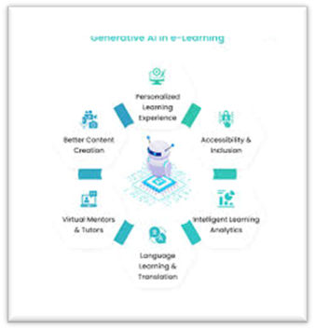

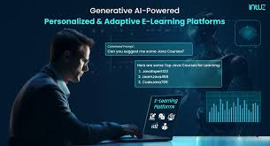

Step-3: Idea Prioritization
